- \Operation\Checkweigher\Feedback controls
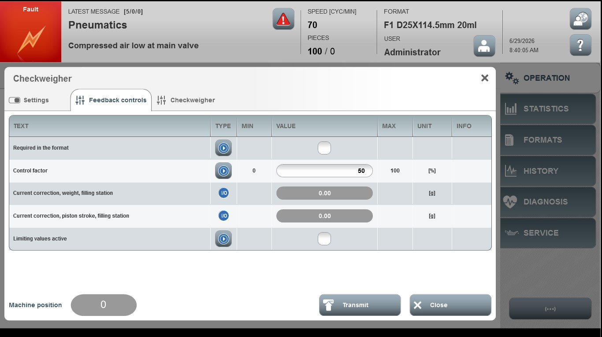
Acceptance criterion | Limits | Pass / Fail: Dev-No. | Date | Initials
Screen matches screenshot | N / A
Control factor | 0 … 100

